**Copying file to another directory**

**Move file to another directory**

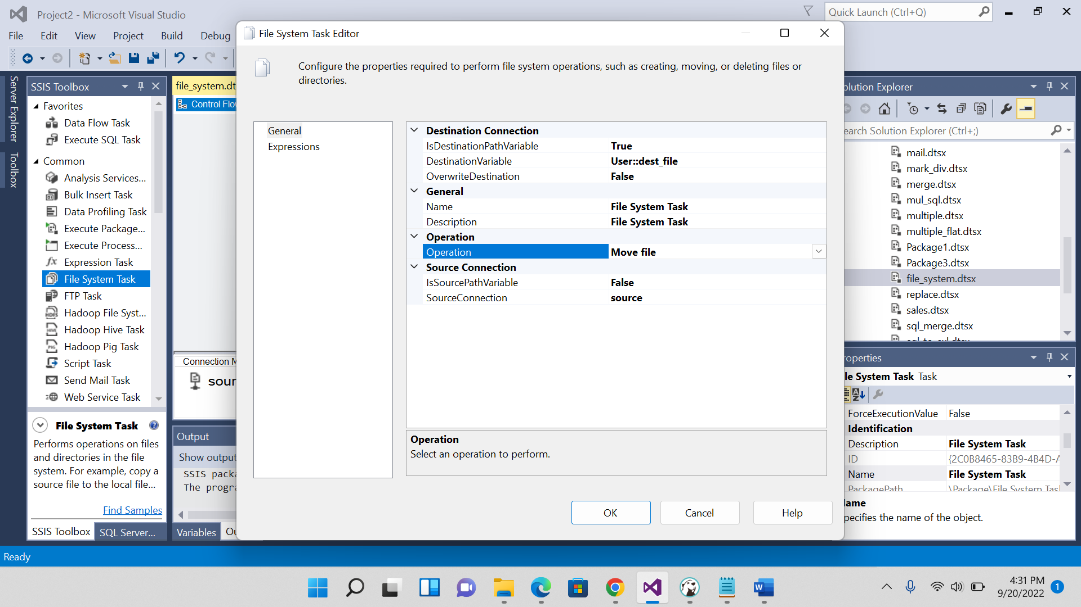

**Deleting file**

